Ticker timers and Speed
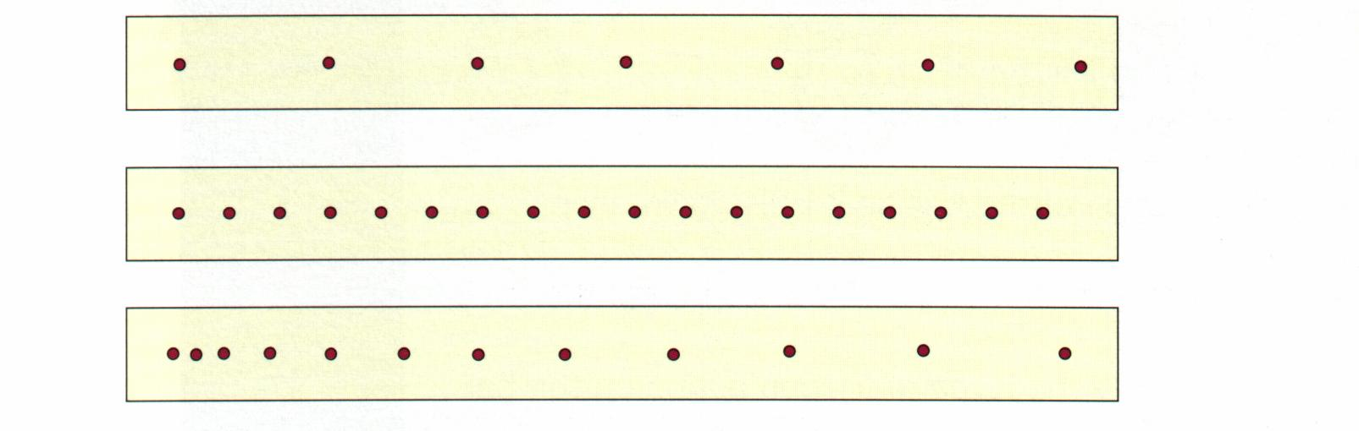
- Use the diagram of the three ticker tapes to answer the following questions
- Which tape shows a different type of motion from the other two?

- Which tapes were attached to an object that was travelling at constant speed?

- Which tape was attached to an object that was travelling the fastest?

- The following diagram shows the pattern of dots left on the ticker tape attached to a moving object.
- What does the pattern of dots indicate about the object’s motion?

- What was the time from when the first dot was made to when the last dot was made?

- How far did the object travel between the first dot and the last dot?

- What was the object’s average speed between making the first dot and the last dot?

